**TEACHING MECHANICAL ENGINEERING WITH**

**INTERACTIVE ASSISTIVE ELEMENTS**

*Vasileios Samaras, Marios Pafitis*

1. **The idea:**

When comes to teacher needs, in order to analyze and demonstrate a mechanical, electrical or any other structure, the most preferable way is to show all the main parts that system consists of and analyze their properties braking apart the structure or virtually present each part over a screen. The problem that arises, is that students are not familiar with the whole system or structure and it’s hard for them to understand and realize how all parts coexist and counteract.

Geometric visualization, spatial perception of problems and geometric reasoning have always been regarded as essential skills for engineering students, but students always encounter problems of lack of visualization skills in the learning process. Augmented-reality (AR) and mixed-reality (MR) technologies provide a promising approach to solve such problems and have been used to help students with object visualization problems [1]. For example, the building information model (BIM) has been used in construction engineering and architectural education for long, where drawbacks in the teaching of BIM are well-known, such as students being unfamiliar with the field operation and decision-making process. MR presents an object in a three-dimensional (3D) representation of its two-dimensional (2D) sketch. Compared with traditional direct observation, students’ visualization skills have improved a lot [2].

Likewise, a possible solution could be an assistive presentation of that system’s assembly with the help of AR or MR, so the teacher shall show both units and parts of a system together with the system assembly in a real time manner. Thus, students shall be able to realize the system straightforwardly and avoid misconceptions. Furthermore, students with different background and skills level, can exercise and realize the system presented with a quiz page that provides information with a depth relevant to their academic level.

So far, a lot of work has been done by the so called ‘3D industry’ [3]–[5] *(AR, VR, Gaming and Marketing development by technical artists and Lead 3D Programmer’s collaboration)* presenting extensive educational solutions with 3d models and animations usually integrated into proprietary software (See: Appendix A). As such, 3d graphical entities, 3D animations, 3D simulations and 3D elements on presentations have become mainstream [6]–[9]. However, there is a very high cost that significantly limits utilization by common users. Open-source software communities like [Open 3D Engine (o3de.org)](https://www.o3de.org/), [Blender](https://www.blender.org/?msclkid=ace9ea22a7c111ec8e51d2dc564e7298), [Godot](https://godotengine.org/?msclkid=c945f652a7c111ecb47c993864126466), Unreal engine plugins, [Unity Open Projects](https://unity.com/open-projects#:~:text=Unity%20Open%20Projects%20is%20a,a%20development%20project%20is%20like.), [Panda3D](https://www.panda3d.org/), [VPython](https://vpython.org/?msclkid=6dc85380a7c211ec9da46b44f850f5e9), etc., are evolving to reach a broader audience though. Inevitably, cost-effective solutions are to an increasing extent for portable AR and VR technologies provided by smartphone-based mobile applications providing tremendous potential for education [10], [11]. AR and VR can both be used effectively to teach science-based information. However, AR and VR have their own set of strengths and weaknesses that should be considered while integrating these technologies into learning environments [12]–[15].

Thus, to mitigate the side effects of these complex architectures and their special requirements, an easier and smarter way is to create customized web applications appending layers of 2D, 3D or pseudo-3D images over a basic background layer. Our aim is to use as little hardware resources (internet bandwidth, GPU utilization, CPU utilization) as possible while maintaining the learning levels high. Since, our web application will be used by mostly students, and usually students use their smartphones for accessing the internet, a lightweight system must be designed to be responsive and enjoyable. At the current stage we will use 2D images for illustrating the different systems, and in the future, we could test 3D images, videos or AR and VR.

1. **Ideas from users in relation to the proposed system**

We define the typical users of the system to two main categories: i) Educators and ii) Scholars. Teachers/Educators shall use the proposed system as an assistive tool to improve the efficacy of their job. Scholars, however, shall use the system as a training tool that can provide valuable feedback to former category at the same time, too.

We also ran a survey questionnaire to evaluate these typical user profiles: see Appendix B.

* 1. **Questionnaire results**

As expected, the results of our survey showed that there are objective problems which make it difficult for the instructor to demonstrate the functioning of a mechanical system so as for the student to realize it. Mechanical systems complexity requires the time-consuming demonstration of each part along with a live assembly/disassembly or the explanation of every individual part’s function which sometimes is impossible to be implemented in such a limited delivery time.

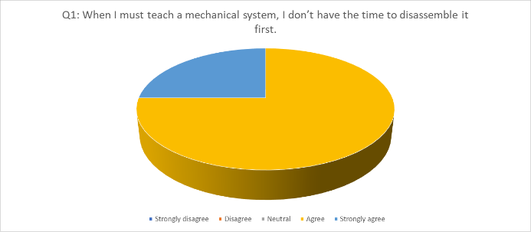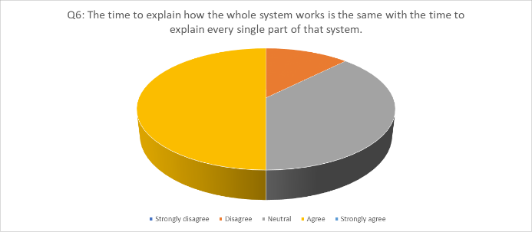

An interim solution to catch up, is to explain the system part by part and then as a whole unit, however, students may fail to realize the complex functions combined without seeing the actual cooperating mechanism part’s assembly.

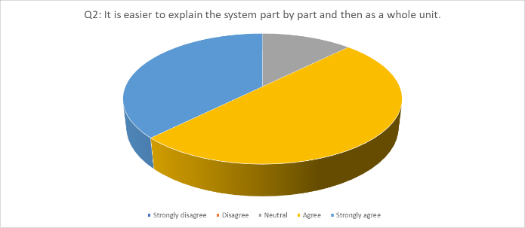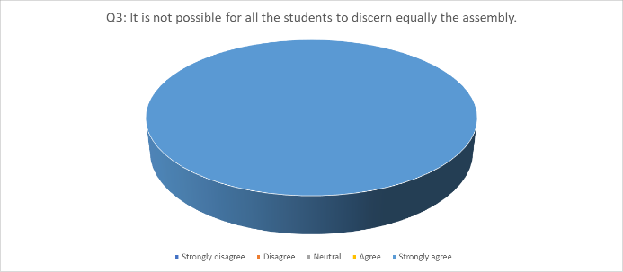

Different class levels and particularities in the learning profile of the students, proves that learning procedure over time is not a static element. Thus, educators may bypass easier parts or reach to a poor result of comprehension depending on time availability.

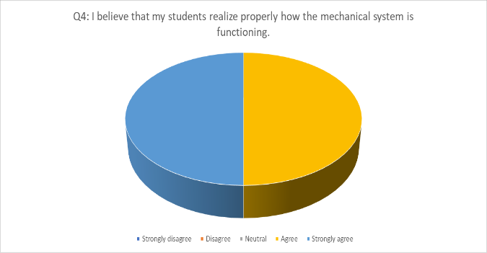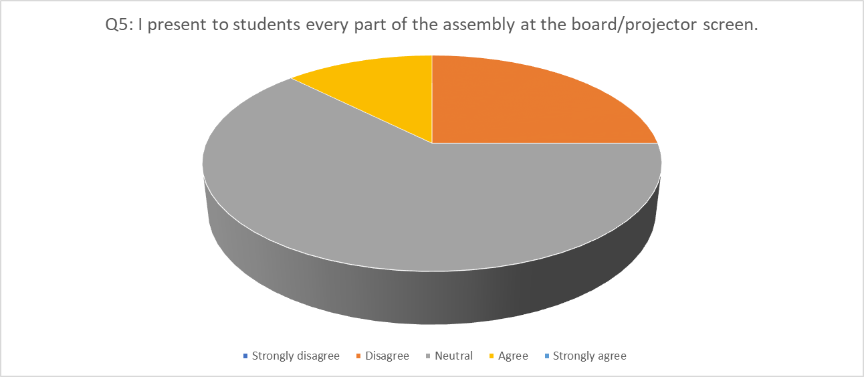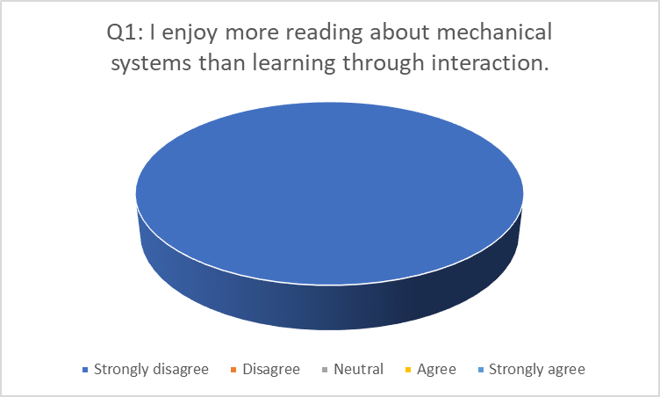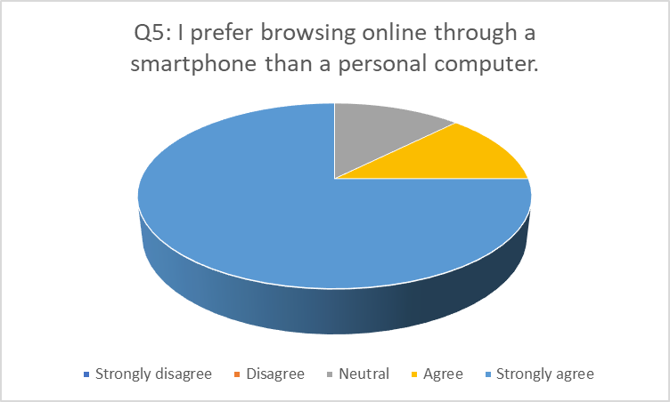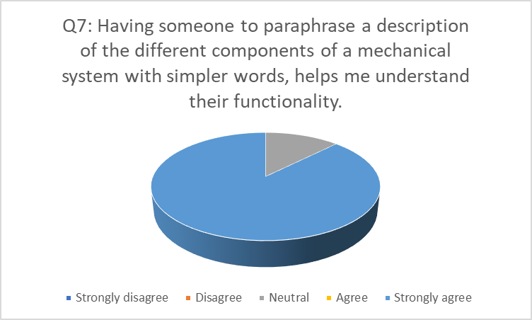

Another concern is the obvious luck of student’s prerequisite knowledge that demands an extra level of simplification and formative assessment to be sure that they understood.

As for the student’s simplicity shake, the profound direct processed information onto their mobile, is their way.

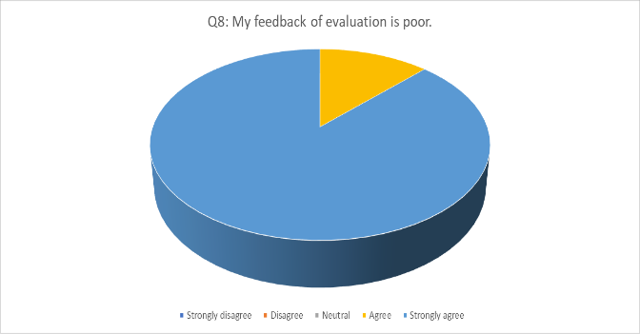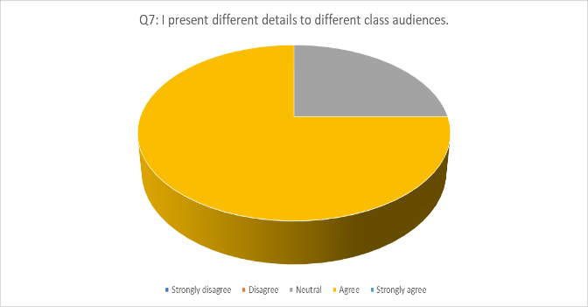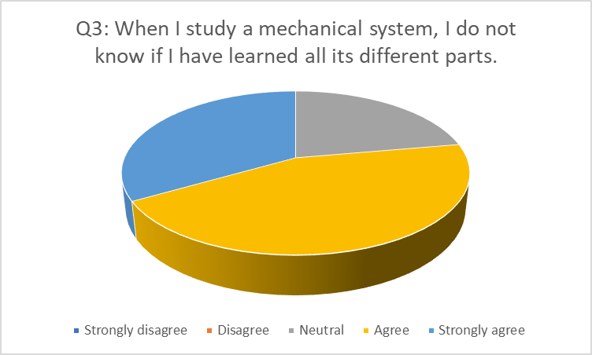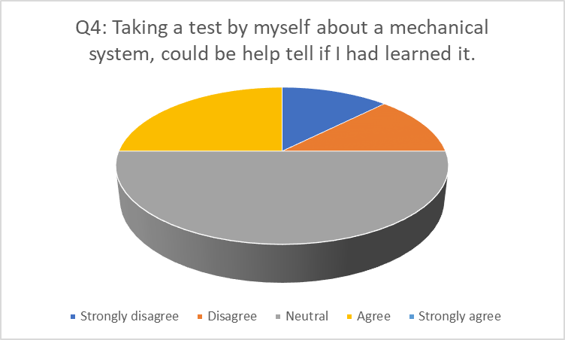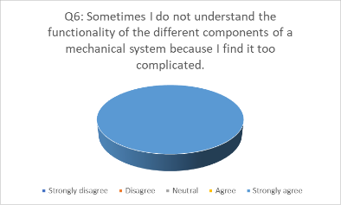

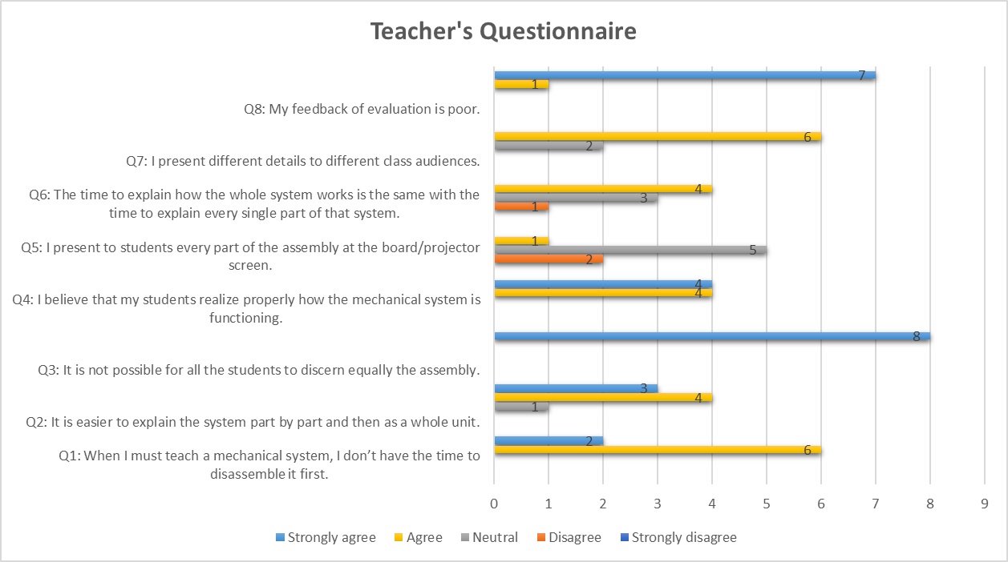

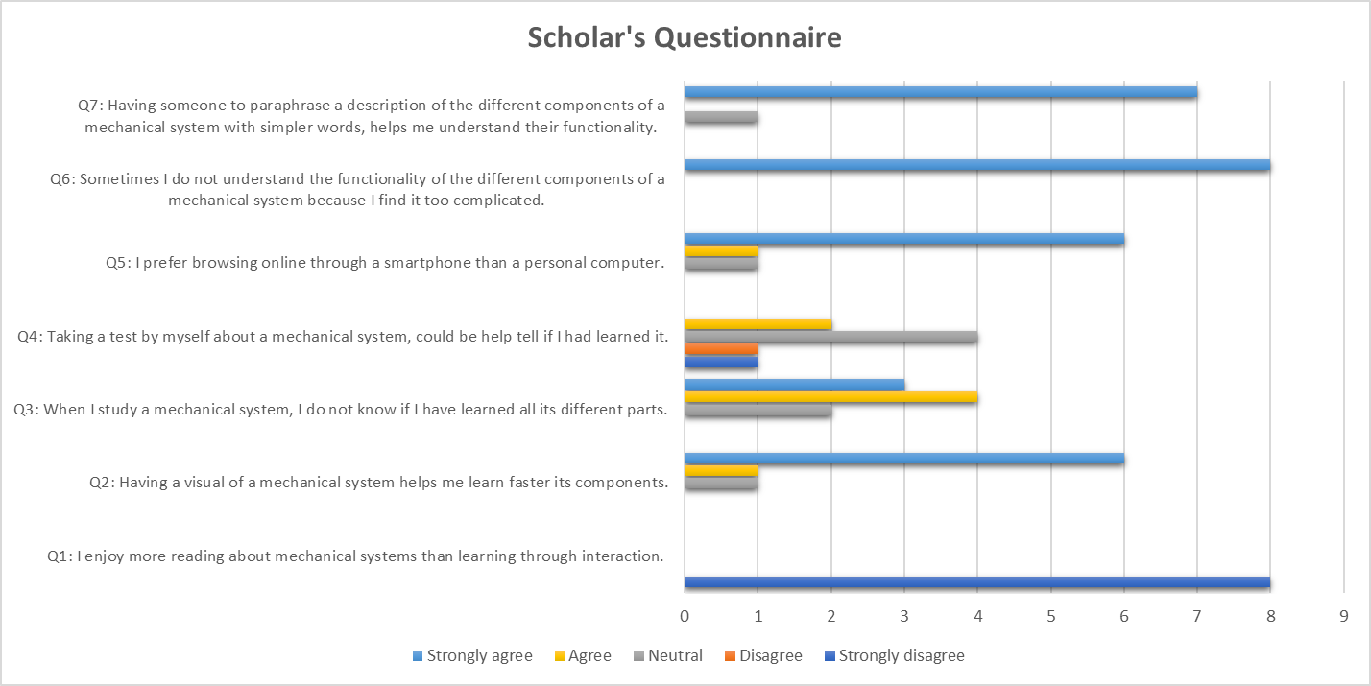

1. **Basics of Design**

The system will be a web application for mechanical engineering students to learn the different components of mechanical systems through an interactive way. The students should be able to test their knowledge on each different system. Different levels of difficulty should be available since the web application will assist high school students and undergraduates as well.

To create a responsive web application, working both on mobile devices, and desktops, the following software and hardware will be utilized.

* + Hardware:
    - The web application will be hosted in a hosting service online (e.g., Hostinger, Amazon AWS)
    - For testing the web application, a private localhost server will be used.
    - 3D VR glasses (desktop) or a camera for AR (mobile) will be used in the final product to see in the real world the scale of the different components of a mechanical system.
  + Software:
    - Angular.js
    - Three.js (library for 3D rendering) - Not to be utilized at the current stage since 2D images will be used.
    - JavaScript
    - Bootstrap
    - HTML, CSS
  + Input/Output devices:
    - Desktop: mouse (left-click, hover, scroll)
    - Mobile: touch
  + Technical Restrictions:
    - Mobile: In the mobile devices since hover is not available, after clicking on a component its description will become visible, while in the desktop after hovering above it.
    - WIMP (Windows, Icons, Menus, Pointers) easy to use interface in the future for uploading models and their descriptions as an educator.

1. **User Requirements Specification**
   1. **Personas**
      1. **Persona 1**



**Name:** Kikkos Kikkou

**Occupation:** Technical School Educator

**Gender:** Male

**Age:** 52 years old

**Bio:**

He is married with 4 children who likes spend time with them during the evenings. He is 11 years at education public sector and was 12 years at heavy-duty tractor services. Has basic computer knowledge and basic English language knowledge. Obtained a BSc in Mechanical Engineering. Teaches a series of automotive technology lessons, likes sports.

As an automotive expert, he can easily handle machinery and mechanical systems. Usually, spends his most time at the school laboratories preparing his everyday lectures and practical workshops on basic automotive systems.

* + 1. **Persona 2**



**Name:** Pambos Anastasiou

**Occupation:** Cyprus Technical School Student

**Gender:** Male

**Age:** 16 years old

**Bio:** He studies vehicle engineering. He usually plays with and services his 50cc motorbike. He spends a lot of time watching tic-toc and talking with girls. He is an average student, and ha poor English knowledge. Usually in the class feels boring. After schools helps at his father’s business.

* + 1. **Persona 3**

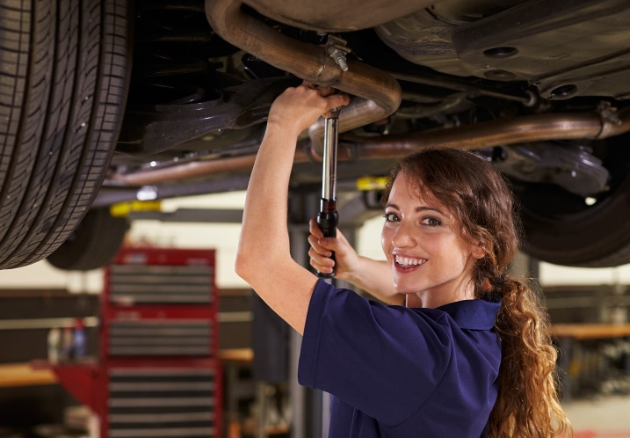

**Name:** Maria Andreou

**Occupation:** BSc Mechanical Engineering

**Gender:** Female

**Age:** 19 years old

**Bio:** She is in her second year of her BSc. She has a lot of friends and enjoys spending a lot of time with them. She in love with Mechanical Engineering so she spends a lot of time studying as well. Her greats are excellent. She is well organized and always trying to spend her time efficiently since she has many responsibilities because she lives alone in a dormitory.

* 1. **Scenarios:**
     1. **Scenario 1**

Kikkos has been teaching a class of 13 students this semester about vehicle engineering. In the last lecture he introduced to them how the brake system works, what are its different components and how it gets assembled. He was talking in the class for 40 minutes alone, trying to show to the students through a power point how the systems functions.

At the afternoon of the same day, he realized that his students most probably didn’t understand a thing about what he said, since they did not participate in the lecture, the did not have questions. He feels disappointed and wants to find an alternative way for transferring this knowledge to his students since the brake system is crucial for every vehicle.

He remembers that a colleague suggested him a website that can help him teach different mechanical engineering systems interactively, so he decides to give it a go. After creating an account, he has the option to upload his own system or selecting one from the existing list. For now, he selects the brake system from the list.

After playing a bit with it, he understands that the descriptions for the different components are a bit too complicated for his students to understand. He finds out that can modify the difficultness teaching level from a drop-down menu, so he selects the option for high school students.

* + 1. **Scenario 2**

Pambos has been playing all the afternoon at his 50cc motorbike since he came home after school. Tomorrow he has a test at school about the suspension system of vehicles. He is so tired and bored to read all the theoretical material that his tutor has provided them.

As an alternative, he tries to study the basics on the website, since he uses it as a refence for his 50cc motorbike repairments as well. He browses for the suspension system in the learning section and selects the difficulty level to high school students. He hovers the mouse above the different components of the beautiful visuals, to reveal their functionality.

After 20 minutes, he leaves the house to hang out with his friends. While being in the car, he opens the website in his smartphone to study a little bit more. From the menu, he loads the system again and by pressing the different points of interests we reveal their description.

* + 1. **Scenario 3**

Maria has the Vehicle Engineering 221 lesson in her second year of studies. In a weak she has a midterm exam which will be mostly focused on the gasoline car engines. She has seen many 2D images about different engines and their components in her textbooks and power point slides provided by her tutor. Also, she watches many videos as well about how an engine functionates.

She has studied a lot about engines but still does not feel confident that she has studied correctly. She remembered that her professor suggested a website where you can test your knowledge on different mechanical systems. After entering the website, she selects to take a quiz in the “engine” system. The website is in Greek, but she changes the language to English since her lessons at the University are in English as well and she is more familiar with the terms.

After taking the quiz, her score 88/100 appears and she decides to create an account on the website to save her results since she plans to use the website for other systems in the future as well. The website shows her the mistakes she did and suggests what the correct answers would be.

* 1. **Site Paths**

In our site path we considered the three main kinds of users that are going to be using our website, plus the job hunter. We have the teacher (persona 1), the student (persona 2), and the mechanical engineer (persona 3).

The teacher and the students will be the user’s that will most probably access our website through our homepage since someone else have already provided them our URL. The mechanical engineer student will most probably find our website randomly when browsing the web searching information for his/er studies.

For a teacher to create the different systems he/she needs to sign in/register on our platform. The students and the mechanical engineer on the other hand can use the website with or without signing up. By signing up the enable extra features such as to save their quiz scores and view their history of results.

The job hunter will access our website through a form or email (contact us). The goal of the job hunter will be to reach us or the teachers to suggest students for potential collaboration.

1. **User’s Requirements Specification:**

**R1:** Scholars shall be able to learn through an interactive process

1. Fast responses when navigating between components
2. Drag-and-drop of components
3. Mouse hovering with pop-ups/modals
4. The content should not be static. It should promote a way of learning through playing
5. Ability to navigate back and forth (start page/previous page). Not feeling restricted by the system.

**R2:** Educators shall be able to create systems for learning and for testing easily

1. Each action should return some feedback (e.g., use sounds, pop-ups)
2. The system should allow them to reuse components (copy/paste)
3. The system should allow them to reverse some action (undo/redo)
4. The system should allow them to save their current state and load the model later.

**R3:** The system should be compatible with different educational levels

1. Different descriptions can be used for explaining the systems’ components based on the student’s level (e.g., high school, university) and the required terminology.

**R4:** Different languages should be supported.

1. English (International language)
2. Greek (Since is going to be used by students in Cyprus)

**R5:** Personal data shall not be provided by the user

1. Since under 18 students will be using the system, no personal data should be stored in the database for privacy.

**R6:** Support of offline mode

1. The system should be usable with a limited number of features even if the students does not sign in or register.
2. In the case of offline mode, cookies can be used for storing only the current stage of the systems and some past scores from the quizzes.

**R7:** Scholars shall be able to test their knowledge on a system

1. The student should be able to undertake tests/quizzes on different vehicle systems.
2. The tests should test three main things:
   1. If the student knows how to assemble a vehicle system
   2. If the student knows the names of the different components of a vehicle system
   3. If the student knows the functionalities of the different components of a vehicle system
3. **Prototype Design & Evaluation.**
   1. **Sketches of Screen: Website View**

Based on fidelity, we started a low fidelity prototype showing and deciding the basic web application behavior. For the supported functionalities, we considered a vertical path having functionality for selected tasks/feature and gradually enrich them.

Initially, we used a throw away prototyping model to proper validate and derive the system requirements. In this initial sketched we focused more on the tutor’s functionalities. In the following stages, after receiving feedback from students as well, we modified the website to be different for students and tutors based on their account that they sign in.

**FILE**

**EDIT**

**VIEW**

**HELP**



**Open**

**Save**

**Close**

**EXIT**

**Undo**

**Redo**

**Edit text**

**Copy**

**Preferences…**

**Path**

**Devices**

**…**

**Nav tools…**

**Test mode**

**Tools…**

**Help…**

**About**

**rotate**

**Zoom**

**Pan**

**reset**

**Car systems…**

**Student’s Level…**

**QUIZ**

**break system**

**clutch**

**engine**

**gearbox**

**other…**

**Easy mode**

**Extensive mode**

**| | S I d e b a r | |**



The teachers will be able to upload their own systems on the website, add their descriptions, images, and create their quizzes. Based on teacher’s indications the structure of the website should be as follows:

* **Navigation Bar**

The navigation bar should have the following tabs:

1. **[File]**

The File tab has basic functions such as:

* + **Open** (load a system)
  + **Save** (save a system)
  + **Close** (close a system)
  + **Exit** (exit/log out)

1. **[Edit]**
   * **Undo** (undo an action)
   * **Redo** (redo an action)
   * **Edit Text** (edit a component’s description or title)
   * **Copy** (copy an element)
   * **{Preferences …}**
     + **Path** (indicates the root path that graphical elements reside)
     + **Devices** (for the 3D (AR) interface – future work)
2. **[View]**
   * **{Nav tools …}**

The navigation tools allow you to change the perspective of your 3D model.

* + - **Rotate** (rotate an element)
    - **Zoom** (zoom an element)
    - **Pan** (pan through screen)
    - **Reset** (reset screen to initial angle)
  + **Test mode** (displays the quiz for the selected car system. The system contains blank boxes where you drag-and-drop the name of the specific component, and the components to the correct place)
  + **{Tools ...}** 
    - **Car systems** (drop-down menu with the different car systems (brake system, engine, transmission system, etc.)
    - **Student’s level** (select student’s level by exposing information in accordance with the level selected for secondary and high school (Easy mode), or for academic level (Extensive mode). Based on the selected level the info texts for the components change accordingly.)

1. **[Quiz]**

Show the quiz under the active car system on the Main Area.

1. **[Help]**
   * **Help** (a link with application instructions)
   * **About** (shows the credits)
2. **Language** (Greek or English)

Change the current language

* **Main Area**

It has two modes in the case of the student. The learning mode and the testing/quiz mode.

1. **Learning Mode**

When selecting a system from the drop-down menu, the learning area updates itself with the current system. The user can interact with the system (zoom in, zoom out, rotate, etc.) and can click in certain points of interests which are indicated with a special icon. When clicking to those points the user can read more about that component from a small pop-up dialog.

1. **Testing Mode**

Displays the test for the selected car system. The system contains blank boxes where you drag-and-drop the name of the specific component.

In the case of a tutor the main area can be modified. So, the tutor can add the different systems and their components in the learning mode and create the corresponding tests for the quiz mode.

* **Sidebar**

The student during the learning mode can hover the mouse above different components and read a description. An alternative way to search for components will be through a sidebar. The sidebar provides in a list of different components of the current system that is displayed in the learning area. When the user clicks a component, the related pop-up dialog appears in the learning area.

* 1. **Sketches of Screen: Application View**

A low fidelity prototype of the application view was designed for the website. The goal was to understand how the responsive elements will adapt to be usable on a smartphone’s screen. Based on our 2nd Scenario, we realized that the student users might not have access to a personal computer. Therefore, the need of a responsive website for mobile devices is essential.

The users can read information about our goal in the home screen (1st row, 1st image), he can navigate through the drawer menu (1st row, 2nd image) and login (1st row, 3rd image) or register (1st row, 4th image).

In the prototype designs the student can learn about a vehicle system (images 2nd row). The user is not required to log in to use the service. From a drop-down menu he can easily switch between different vehicle systems. When learning a system, he can click the points of interest to read a description about a system’s component which is shown as a modal (2nd row, 1st and 2nd images). For each vehicle system, a 3D preview of the system is available where the user can zoom in, zoom out, rotate, and explode to isolate the different components (2nd row, 3rd image). From the sidebar, the user can view a list of all the different components of the current system, and rapidly switch between their descriptions (2nd row, 4th image).

In the prototype we demonstrate the experience of a student taking a quiz (images 3rd row). The user can drag-and-drop the components to the correct location in order to assemble the vehicle system (3rd row, 1st image). Moreover, the user can match the name of the components with their image (3rd row, 2nd image). Additionally, the student can match the description about the functionality of a component with the correct image (3rd row, 3rd image). After pressing the “Done” button, the quiz is graded and the score is displayed (3rd row, 4th image). Finally, the mistakes are presented alongside the correct answers.

The tutor, after signing up can create a new system or view systems that has already created. The user can create a new system. Firstly, to create a new system, the different components of the system need to be created by defining their image, their description and their name (4th row, 1st image). Secondly, a 3D model of the system needs to be uploaded. The top menu (File, Edit, View, Help) gives access to the user to several functionalities, such as saving the model, loading a model, copy/cut/paste elements etc. (4th row, 2nd image). The drawer menu adapts to support tutor’s functionalities (4th row, 3rd image). Through the drawer menu, the user has access to his history of vehicle systems where he can view, edit or delete them (4th row, 4th image).

* 1. **Prototype: Website View**

We have used Bootstrap, JavaScript, HTML, CSS and jQuery to create a medium fidelity prototype of the Website View. Simple functionalities were implemented. Examples of such functionalities are the drop-down menus, the navigation between sides, drag-and-drop of images (Quiz Tab) and area mapping on images (Learn Tab).

We decided to give access to the tutors on uploading their systems only after signing up on our platform. Additionally, the students will be able to sign in to track their performance on the quizzes that have completed.

**Home Tab:**

The home screen will display some information about the software (e.g., what is this tool, how you can use it (as a tutor, as a student)) (fig. 1).

Figure **Error! No text of specified style in document.**1. Prototype Website View: Home Tab

**Learn Tab:**

The learn screen displays information about a vehicle system. You can check the selected system from the “System” drop-down menu (fig. 6).

This screen will display a summary about the vehicle system and how it functionates. Also, several interactive points of interest (pink circles) will be located on top of the images (fig. 2). By hovering the mouse over those points you can read a description about that component (fig. 3).

A 3D-preview of the certain vehicle system will be visible as well where you will be able to isolate its components, rotate it or zoom it, to examine further the structure and how it is assembled.

Figure 2. Prototype Website View: Learn Tab

Figure 3. Prototype Website View: Learn Tab. Hovering over a point of interest to read description of a vehicle system's component.

**Quiz Tab:**

In the quiz tab you can test your knowledge on different vehicle systems (fig. 4). You can drag-and-drop the components to the correct location to assemble the system (fig. 5). Also, you can match the description of the functionalities of the different components.

Figure 4. Prototype Website View: Quiz Tab. Drag and drop the components of the vehicle system to the correct location to assemble the system.

Figure 5. Prototype Website View: Quiz Tab. Drag-and-dropping functionality demonstrated.

While being in the Quiz tab, you can check the selected system to test yourself on, from the “System” drop-down menu (fig. 6).

Figure 6. Prototype Website View: Quiz Tab. Select the current vehicle system to test on.

At any given time, you can change the languages of the website from the drop-down menu. The supported languages initially will be “English” and “Greek” (fig. 7).

Figure 7. Prototype Website View: Change the language.

1. **Developer’s Software Specifications**
   1. **Functional Requirements**
      1. **Onboarding (Home Tab)**
   * When entering the website, the user will view the home screen with some information about the website and its functionality.
   * The user can select to Log In, Change Language, navigate to the Learn tab or the Quiz tab.
   * The user can change the language of the website. The supported languages will be “English” and “Greek”.
   * The user should be able to access the “Help” section
     + Frequently Asked Questions (FAQ)
     + Contact us/Support (through email)
   * The user should be able to access the “About us” section where he can learn more about the business and how to contact us for potential collaborations.
     1. **Log In**
   * If the user has an account, he can log in, otherwise he can register.
   * The user can reset the password
     1. **Register**
   * The user should provide some information for registration, the email, a password, confirm password and the type of the account the user wants to create (tutor, student).
   * After registering, a 6-digit numeric code will be sent to the user’s email. The user will enter the code to the verify screen after registration, to verify the email.
     1. **Learn Tab – Student (log in as student / no log in)**
   * The user will be able to get information about a vehicle system. The information will be the name of the system, and a summary about what the system is.
   * A 2D image of the system will be visible where several interactive points of interest will be located over the different components of the system. When hovering over those points of interest, a modal should be shown displaying a title and a description about the specific component.
   * A sidebar menu will list the names of the different components of the system. When clicking a name from the list the corresponding modal will be shown above that component on the image.
   * A 3D image of the system will be visible where the user can zoom, rotate, and disassemble the system.
   * The user should be able to change the current system from a drop-down menu
   * The user should be able to change the current difficulty level (easy, medium, hard) where the descriptions of the components change appropriately.
   * To assist people with accessibility issues, they should be able to listen the descriptions by selecting the corresponding icon, through a text-to-speech algorithm.
     1. **Quiz Tab (log in as student / not logged in)**
   * The user will be able to take a quiz on the selected system.
   * The user should be able to change the current system from a drop-down menu
   * The quiz will examine two main elements
     + The structure of the system. The user should drag-and-drop an image of a component to the correct location to assemble the system.
     + The naming of the components. The user should match the name of a component with the correct image and the correct description about the functionality of that component.
   * After completing the test, the exam will be graded and a score out of 100 will be shown. If the user is logged in, the score will automatically save on the database. If the user is not logged, he will be advised to log in.
   * The user should be able to change the current difficulty level (easy, medium, hard) where the descriptions of the components change accordingly.
     1. **Tutor (log in as tutor)**
   * The user should be able to create a new vehicle system by:
     + Uploading a 2D image of the whole system
     + Uploading a 3D image of the whole system
     + Uploading a 2D image for each component of the system
     + A summary about the system
     + A description and a name for each one of the components of the system
       - For each components several descriptions should be provided for the different difficulty levels (easy, medium, hard)
       - The user should provide a pre-recorded .mp3 file of the descriptions for people with accessibility limitations. If the user doesn’t provide a pre-recorded description, the text-to-speech algorithm will be used.
   * The user should be able to save/load the system
   * The user should be able to redo/undo changes
   * The user should be able to cut/copy/paste an element
   * The user should be able to view the 3D image of the system in a way where he can zoom, rotate, pan, and isolate its components.
   * The user should be able to create a quiz
     + Form a puzzle like shape of the system
     + Drag-and-drop images/descriptions/names of the components to the relevant place
     1. **Log Out**
   * The user should be able to log out if is already logged in
     1. **Settings**
   * Delete my account
   * Support
   1. **Non-Functional Requirements**
      1. **Dark ode support**
   * The user should be able to change from light mode to dark mode and vice versa through the settings
     1. **Language support**
   * English
   * Greek
     1. **Accessibility issues**
   * Support people with blindness and low vision by providing audio in the place of the different descriptions (text-to-speech)
   * Provide audio navigation
   * Add accessibility captions to the images
     1. **Security**
   * The passwords of the user store in the database should be hashed (SHA-256)
   * The web application should be stored in a secured hosting server
   * The web application should have active SSL certificates
   * The web application should be robust against DDOS attacks (Cloudflare)
   1. **Data Management**
      1. **Data Stored – Database**
   * Both
     + Email
     + Password
     + Account Type
   * Student
     + Grades History
     + Learning Progress
   * Tutor
     + Saved Vehicle Systems
       - 2D images
       - 3D images
       - Descriptions
     1. **Data Stored – Browser**
   * The web application should keep some cookies to maintain a great level of user experience even if the user is not logged in
     + Selected language
     + Selected difficulty level
     + Grades History
2. **Design Language**

In this section, several examples of user interface designs that were found online are presented. Similar design language should be followed for the web application as well. The design should be minimalistic but colorful as well to maintain user’s interest for long periods of time.

Our points of interest can be similar to the ones in the figure 8 (red circles over the C-HR). Moreover, a similar style sidebar to figure 8, can be used in our website’s “Learn Tab” where the list of components will be displayed. The combination of the colors red, black and white is interesting (fig. 8 & 13).

The buttons in figure 10 are clean with a soft shadow, which provide some depth in the website. This sense of depth could match the theme of our website since we will have 3D models of vehicles. The grades from past quizzes can be displayed in a similar manner as in figure 12. In the form of a circle, where each color represents the different kinds of mistakes.

Figure 8. Design sample 1

Figure 9. Design sample 2

Figure 10. Design sample 3

Figure 11. Design sample 4

Figure 12. Design sample 5

Figure 13. Design sample 6

1. **Experiences**

Through this project we realized how difficult is to transfer your throughs about a design to someone else. The above procedure allowed us to understand our customer and show them what we have in mind. Not only that, but it also helped us understand what each one of us was thinking the system will do. The low-fidelity prototypes were essential for concluding on how the system will behave. In the meantime, the scenarios were crucial for identifying unknown requirements, such as the need for a log in system, or the need for cookies.

We realized also, that it is important to design differently a web view and an application view. At first, the transition seems trivial, but in practice there are different design principles. For example, how the navigation works on a smartphone device, or how does a sidebar expands. Also, in a personal computer you have a keyboard and mouse to interact with the website, while in a smartphone only your fingers. So, functionalities such as Crtl + c, Crtl + v for copy pasting are not allowed on a smartphone. Mouse hovering is not a thing as well. This made us think different ways to express the same functionalities without sacrificing the user’s experience quality.

**Appendix A**

Web resources tools and applications on immersive, augmented, and virtual reality deployments.

Web AR

<https://en.wikipedia.org/wiki/Augmented_web>

<https://ar-link.net/ar-demos/rims/>

<https://www.whatiswebar.com/>

<https://createwebxr.com/webAR.html>

<https://www.banuba.com/blog/best-web-ar-platforms-and-tools>

<https://gravityjack.com/news/webar-handbook/>

<https://www.8thwall.com/discover/automotive>

<https://rockpaperreality.com/web-ar/how-does-web-based-augmented-reality-work/>

AR links & trends

<https://mobidev.biz/blog/augmented-reality-trends-future-ar-technologies>

<https://library.harvard.edu/services-tools/teaching-and-learning-3d-content>

<https://www.educause.edu/ecar/research-publications/learning-in-three-dimensions-report-on-the-educause-hp-campus-of-the-future-project/pedagogical-uses-of-3d-tech>

<https://www.iste.org/explore/Computer-Science/Harness-the-power-of-3D-models-in-the-classroom>

<https://medium.com/@ImaginusVR/why-3d-models-are-great-for-education-692b2f9c03ab>

<https://www.emerald.com/insight/content/doi/10.1108/JARHE-06-2020-0172/full/html>

<https://blogs.oregonstate.edu/inspire/2018/08/15/5-ways-3d-models-can-help-in-education/>

<https://www.researchgate.net/publication/295264063_Using_3D_Modeling_Techniques_to_Enhance_Teaching_of_Difficult_Anatomical_Concepts>

[HTML Image Maps (w3schools.com)](https://www.w3schools.com/html/html_images_imagemap.asp)

AR/VR (XR) solutions

<https://semcon.com/>

<https://semcon.com/offerings/training-solutions/authoring-tools/>

<https://www.arvizio.io/>

<https://program-ace.com/blog/augmented-reality-sdk/>

<https://www.inglobetechnologies.com/ar-media>

<https://www.youtube.com/watch?v=1t1gBVykneA> magic window 2d

<https://aframe.io/>

<https://developers.google.com/web/updates/2018/06/ar-for-the-web>

**Appendix B:**

Questionnaire from users in relation to the proposed system

1. ***Teacher/educator as a user (Likert scale):***

|  |  |  |  |  |  |
| --- | --- | --- | --- | --- | --- |
| **Question** | **Strongly disagree** | **Disagree** | **Neutral** | **Agree** | **Strongly agree** |
| **Q1: When I must teach a mechanical system, I don’t have the time to disassemble it first.** | **□** | **□** | **□** | **□** | **□** |
| **Q2: It is easier to explain the system part by part and then as a whole unit.** | **□** | **□** | **□** | **□** | **□** |
| **Q3: It is not possible for all the students to discern equally the assembly.** | **□** | **□** | **□** | **□** | **□** |
| **Q4: I believe that my students realize properly how the mechanical system is functioning.** | **□** | **□** | **□** | **□** | **□** |
| **Q5: I present to students every part of the assembly at the board/projector screen.** | **□** | **□** | **□** | **□** | **□** |
| **Q6: The time to explain how the whole system works is the same with the time to explain every single part of that system.** | **□** | **□** | **□** | **□** | **□** |
| **Q7: I present different details to different class audiences.** | **□** | **□** | **□** | **□** | **□** |
| **Q8: My feedback of evaluation is poor.** | **□** | **□** | **□** | **□** | **□** |

1. ***ii. Scholar as a user (Likert scale):***

|  |  |  |  |  |  |
| --- | --- | --- | --- | --- | --- |
| **Question** | **Strongly disagree** | **Disagree** | **Neutral** | **Agree** | **Strongly agree** |
| **Q1: I enjoy more reading about mechanical systems than learning through interaction.** | **□** | **□** | **□** | **□** | **□** |
| **Q2: Having a visual of a mechanical system helps me learn faster its components.** | **□** | **□** | **□** | **□** | **□** |
| **Q3: When I study a mechanical system, I do not know if I have learned all its different parts.** | **□** | **□** | **□** | **□** | **□** |
| **Q4: Taking a test by myself about a mechanical system, could be help tell if I had learned it.** | **□** | **□** | **□** | **□** | **□** |
| **Q5: I prefer browsing online through a smartphone than a personal computer.** | **□** | **□** | **□** | **□** | **□** |
| **Q6: Sometimes I do not understand the functionality of the different components of a mechanical system because I find it too complicated.** | **□** | **□** | **□** | **□** | **□** |
| **Q7: Having someone to paraphrase a description of the different components of a mechanical system with simpler words, helps me understand their functionality.** | **□** | **□** | **□** | **□** | **□** |

The Survey questionnaire were addressed to two main groups, automotive engineering educators and their students at a Cypriot technical school in Nicosia with the following results:

|  |  |  |  |  |  |
| --- | --- | --- | --- | --- | --- |
| Teacher's Questionnaire | | | | | |
| **Question** | **Strongly disagree** | **Disagree** | **Neutral** | **Agree** | **Strongly agree** |
| **Q1: When I must teach a mechanical system, I don’t have the time to disassemble it first.** |  |  |  | **6** | **2** |
| **Q2: It is easier to explain the system part by part and then as a whole unit.** |  |  | **1** | **4** | **3** |
| **Q3: It is not possible for all the students to discern equally the assembly.** |  |  |  |  | **8** |
| **Q4: I believe that my students realize properly how the mechanical system is functioning.** |  |  |  | **4** | **4** |
| **Q5: I present to students every part of the assembly at the board/projector screen.** |  | **2** | **5** | **1** |  |
| **Q6: The time to explain how the whole system works is the same with the time to explain every single part of that system.** |  | **1** | **3** | **4** |  |
| **Q7: I present different details to different class audiences.** |  |  | **2** | **6** |  |
| **Q8: My feedback of evaluation is poor.** |  |  |  | **1** | **7** |

|  |  |  |  |  |  |
| --- | --- | --- | --- | --- | --- |
| **Student’s Questionnaire** | | | | | |
| **Question** | **Strongly disagree** | **Disagree** | **Neutral** | **Agree** | **Strongly agree** |
| **Q1: I enjoy more reading about mechanical systems than learning through interaction.** | **8** |  |  |  |  |
| **Q2: Having a visual of a mechanical system helps me learn faster its components.** |  |  | **1** | **1** | **6** |
| **Q3: When I study a mechanical system, I do not know if I have learned all its different parts.** |  |  | **2** | **4** | **3** |
| **Q4: Taking a test by myself about a mechanical system, could be help tell if I had learned it.** | **1** | **1** | **4** | **2** |  |
| **Q5: I prefer browsing online through a smartphone than a personal computer.** |  |  | **1** | **1** | **6** |
| **Q6: Sometimes I do not understand the functionality of the different components of a mechanical system because I find it too complicated.** |  |  |  |  | **8** |
| **Q7: Having someone to paraphrase a description of the different components of a mechanical system with simpler words, helps me understand their functionality.** |  |  | **1** |  | **7** |

**Appendix C:**

Resources

[1] S. Tumkor, “Personalization of engineering education with the mixed reality mobile applications,” *Comput Appl Eng Educ*, vol. 26, no. 5, pp. 1734–1741, Sep. 2018, doi: 10.1002/cae.21942.

[2] H. Zhang *et al.*, “Hotspots and trends of virtual reality, augmented reality and mixed reality in education field,” in *2020 6th International Conference of the Immersive Learning Research Network (iLRN)*, 2020, pp. 215–219.

[3] S. Chong, G.-T. Pan, J. Chin, P. Show, T. Yang, and C.-M. Huang, “Integration of 3D Printing and Industry 4.0 into Engineering Teaching,” *Sustainability*, vol. 10, no. 11, p. 3960, Oct. 2018, doi: 10.3390/su10113960.

[4] E. H. P. Utama, D. K. Basuki, and S. Sukaridhoto, “3D Asset for Web-based Virtual Engineering Platfrom as Implementation of Industry 4.0,” in *2020 International Conference on Applied Science and Technology (iCAST)*, Padang, Indonesia, Oct. 2020, pp. 640–645. doi: 10.1109/iCAST51016.2020.9557636.

[5] U. Gal, K. Lyytinen, and Y. Yoo, “The dynamics of IT boundary objects, information infrastructures, and organisational identities: the introduction of 3D modelling technologies into the architecture, engineering, and construction industry,” *European Journal of Information Systems*, vol. 17, no. 3, pp. 290–304, Jun. 2008, doi: 10.1057/ejis.2008.13.

[6] T. Hattori, R. Masuda, Y. Moritoh, Y. Imai, Y. Kawakami, and T. Tanaka, “Utilization of Both Free 3DCG Software ‘Blender’ and 3D Printing for Early STEM Education,” in *2020 IEEE International Conference on Teaching, Assessment, and Learning for Engineering (TALE)*, Takamatsu, Japan, Dec. 2020, pp. 879–882. doi: 10.1109/TALE48869.2020.9368379.

[7] Liqing Huang and Mingzhu Li, “Some thoughts on 3D graphics software and industrial design education,” in *2009 IEEE 10th International Conference on Computer-Aided Industrial Design & Conceptual Design*, Wenzhou, China, Nov. 2009, pp. 165–167. doi: 10.1109/CAIDCD.2009.5375150.

[8] N. M. M. Barkhaya and N. D. Abd Halim, “A review of application of 3D hologram in education: A meta-analysis,” in *2016 IEEE 8th International Conference on Engineering Education (ICEED)*, Kuala Lumpur, Dec. 2016, pp. 257–260. doi: 10.1109/ICEED.2016.7856083.

[9] J. S. Ortiz, B. S. Guevara, E. G. Espinosa, J. Santana, L. R. Tamayo, and V. H. Andaluz, “3D Virtual Content for Education Applications,” in *2020 15th Iberian Conference on Information Systems and Technologies (CISTI)*, Sevilla, Spain, Jun. 2020, pp. 1–5. doi: 10.23919/CISTI49556.2020.9140822.

[10] Y. Slavova and M. Mu, “A Comparative Study of the Learning Outcomes and Experience of VR in Education,” in *2018 IEEE Conference on Virtual Reality and 3D User Interfaces (VR)*, Reutlingen, Mar. 2018, pp. 685–686. doi: 10.1109/VR.2018.8446486.

[11] C. Pittman and J. J. LaViola, “Determining Design Requirements for AR Physics Education Applications,” in *2019 IEEE Conference on Virtual Reality and 3D User Interfaces (VR)*, Osaka, Japan, Mar. 2019, pp. 1126–1127. doi: 10.1109/VR.2019.8797908.

[12] K.-T. Huang, C. Ball, J. Francis, R. Ratan, J. Boumis, and J. Fordham, “Augmented Versus Virtual Reality in Education: An Exploratory Study Examining Science Knowledge Retention When Using Augmented Reality/Virtual Reality Mobile Applications,” *Cyberpsychology, Behavior, and Social Networking*, vol. 22, no. 2, pp. 105–110, Feb. 2019, doi: 10.1089/cyber.2018.0150.

[13] K. C. Raju, K. Yugandhar, D. V. N. Bharathi, and N. Vegesna, “3D Based Modern Education System Using Augumented Reality,” in *2018 IEEE 6th International Conference on MOOCs, Innovation and Technology in Education (MITE)*, Hyderabad, India, Nov. 2018, pp. 37–42. doi: 10.1109/MITE.2018.8747078.

[14] Heen Chen, Kaiping Feng, Chunliu Mo, Siyuan Cheng, Zhongning Guo, and Yizhu Huang, “Application of Augmented Reality in Engineering Graphics Education,” in *2011 IEEE International Symposium on IT in Medicine and Education*, Guangzhou, China, Dec. 2011, pp. 362–365. doi: 10.1109/ITiME.2011.6132125.

[15] H. Z. Tibor, “Another e-learning method in upper primary school: 3D spaces,” in *2018 9th IEEE International Conference on Cognitive Infocommunications (CogInfoCom)*, Budapest, Hungary, Aug. 2018, pp. 000405–000410. doi: 10.1109/CogInfoCom.2018.8639937.